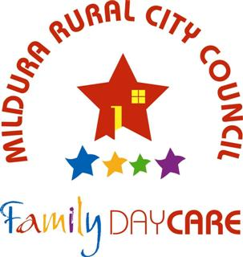 | Mildura Family Day Care Service Request for Care Form
Privacy Collection Statement
All personal and/or health information collected by Mildura Rural City Council Family Day Care is used to enable us to provide quality care and education for your child attending Mildura Rural City Council Family Day Care and to enable us to manage, monitor and administer the service as we are required. The personal and/or health information will be used solely by Mildura Rural City Council Family Day Care for this purpose and/or directly related purposes. Mildura Rural City Council Family Day Care may disclose this information to other organisations if required by legislation e.g. To the Department of Social Services (DSS) for the administration of Child Care Subsidy (CCS). The parent understands that the personal and/or health information provided is for the above purpose and that he or she may apply to Mildura Rural City Council for access to and/or amendment of the information. Requests for access and/or correction should be made to Council's Private officer.
Request for Care
Thank you for your interest in Mildura Family Day Care service.

Please complete this form in full, indicating the type of care and times you require and return it by email to fdcinfo@mildura.vic.gov.au

Please complete one form for each child

Placement Process

This request for care form will be processed by a staff member who will call or email you to confirm that your form has been received and to discuss your care requirements with you.

Please advise the Coordination Unit immediately if there are any changes to your family circumstances for example, if you move house, need different days or no longer require care.

As vacancies fluctuate, we will start looking at placing your child approximately two weeks before the date you require care. If you prefer to start sooner to secure a place, please discuss this with us when we contact you or indicate this on the form.

If you have any questions about our service, placement process, fees or immunisation requirements please contact the Coordination Unit on 5018 8271.
Child Information
Child’s First name: |  |  |  |  | Family name:
Gender: Male Female |  |  |  |  | Date of Birth:
Country of Birth: |  |  |  |  | Ethnic Group:
Indigenous or TS Islander: Yes No |  |  |  |  | Primary Language:
Parent Information
First name: |  |  |  |  | Family name:
Email: |  |  |  |  |  | Date of Birth:
Address: |  |  |  |  | Relationship to child:
Customer Reference Number: |  |  |  |  | Home phone:
Work Place/Study: |  |  |  |  | Mobile:
Occupation: |  |  |  |  | Work phone:
Alternative contact person
First name: |  |  |  |  | Family name:
Contact number: |  |  |  |  | Relationship to the child
Medical Information
Mildura Family Day Care is committed to providing quality care for all children including children with additional needs.
Does your child have any conditions or concerns that we need to be aware of Yes No
Please provide details:
Days care required
 | Monday | Tuesday | Wednesday | Thursday |  |  | Friday | Saturday | Sunday
Start
Finish
Start
Finish
Type of care Required
Permanent Temporary Casual Shift/Roster Before/After school

Name of school attending School holidays

Do you have transport? Yes No
Name of preferred Educators
Care Requirements
When do you require care to commence?
Are you flexible with your days and times of care?
Parent name:
Parent Signature:
Date form Completed:
Office use only
Date received: Parent Contacted: Email Phone Name of Person who contacted:
Notes:

