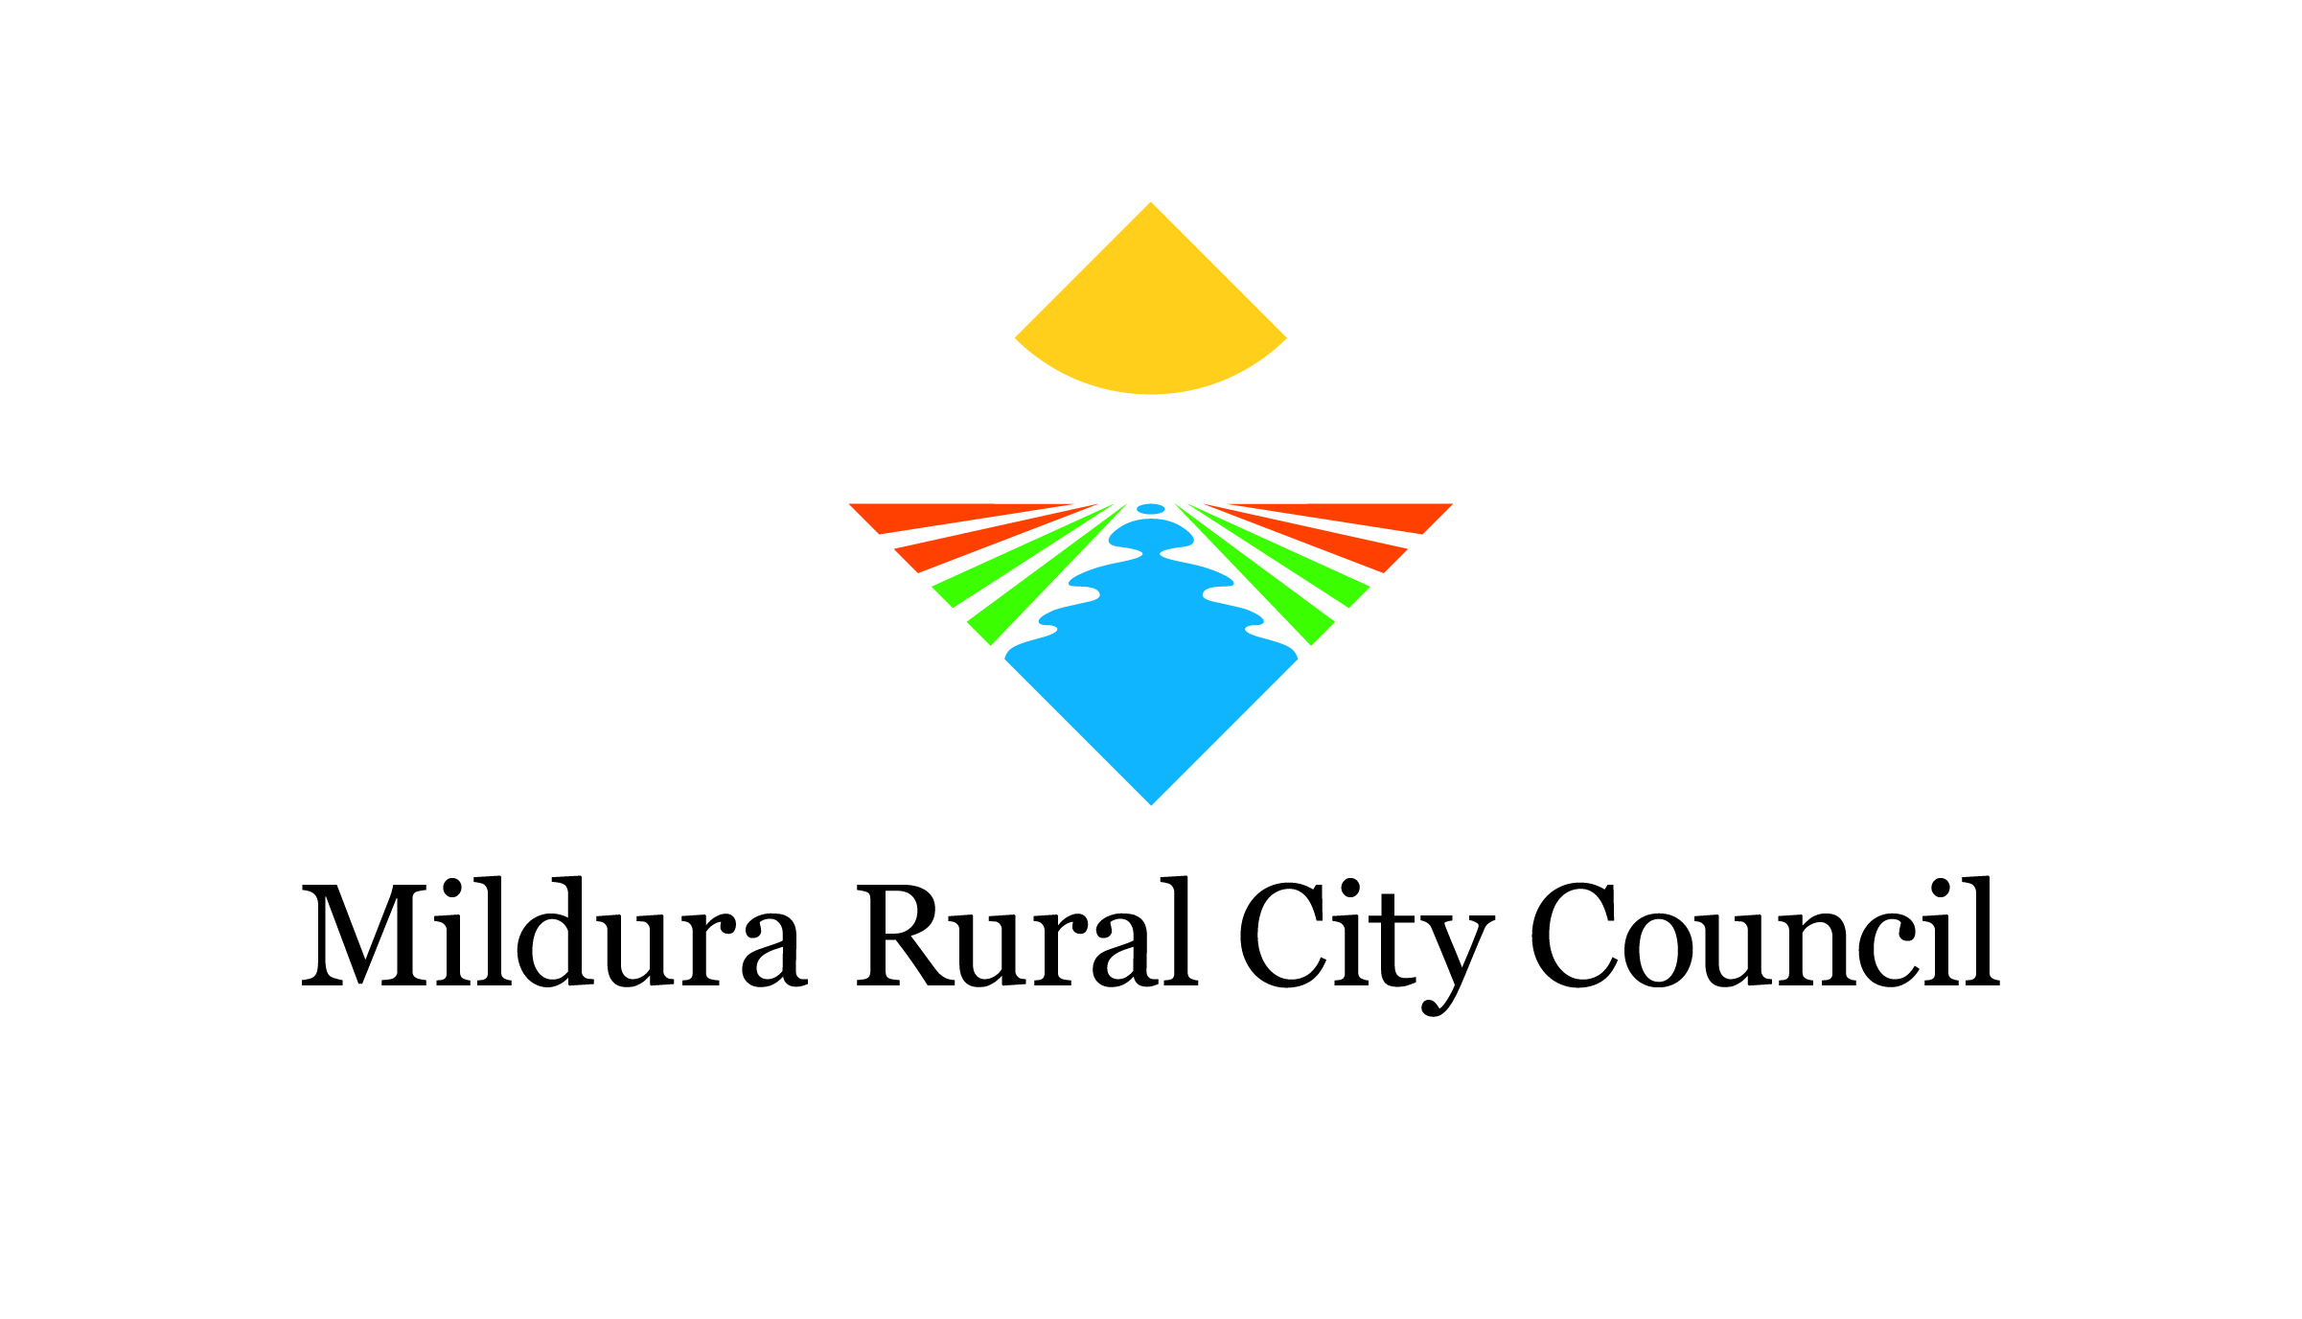
VISITOR SURVEY template

TEMPLATE VISITOR SURVEY
To ensure the community and committee can continually improve and grow the event, we invite you to provide feedback on your experience via our quick survey.

1. Are you male or female? (Circle)
Male Female

2. What is your age? (Circle)
Under 17
18-25
26-35
36-45
46-55
56-65
Over 66

3. Where do you normally live?
Town
State
Postcode
Country (if outside Australia)

4. Did you travel to <<event name>> specifically to attend the event? (Circle)
Yes No

If no, did you extend your stay in <<local town name>> to attend <<event name>>? (Circle)
Yes No

5. How many nights in total did you spend in <<local town name>> on this trip? (Circle)
0 (Resident or day-tripper)
1
2
3
4 or more

6. If visiting, how many nights did you spend in other parts of <<state>> during this trip?
1
2
3
4 or more

7. How much money did you spend in total in <<local town name>> during this trip, both for yourself and for other people travelling with you?
Food and drink:
Accommodation:
Transport:
Tickets:
Attractions:
Retail purchases:

8. Who did you attend the event with? (Circle)
Alone
Friend/s
Partner
Young family (children aged 12 and under)
Older family (children aged 13 and over)
Social, community or sporting group

9. What did you enjoy most about this year’s event?

10. What elements of the event do you think can be improved in the future and how?

11. Please take the time to write a short testimonial about <<event name>> to be used in the future for marketing/promotional purposes

12. Thank you for completing our survey. If you would like to be informed about the event in the future, please enter your email address below

Tip: Consider a prize or incentive to encourage visitors to complete your survey

