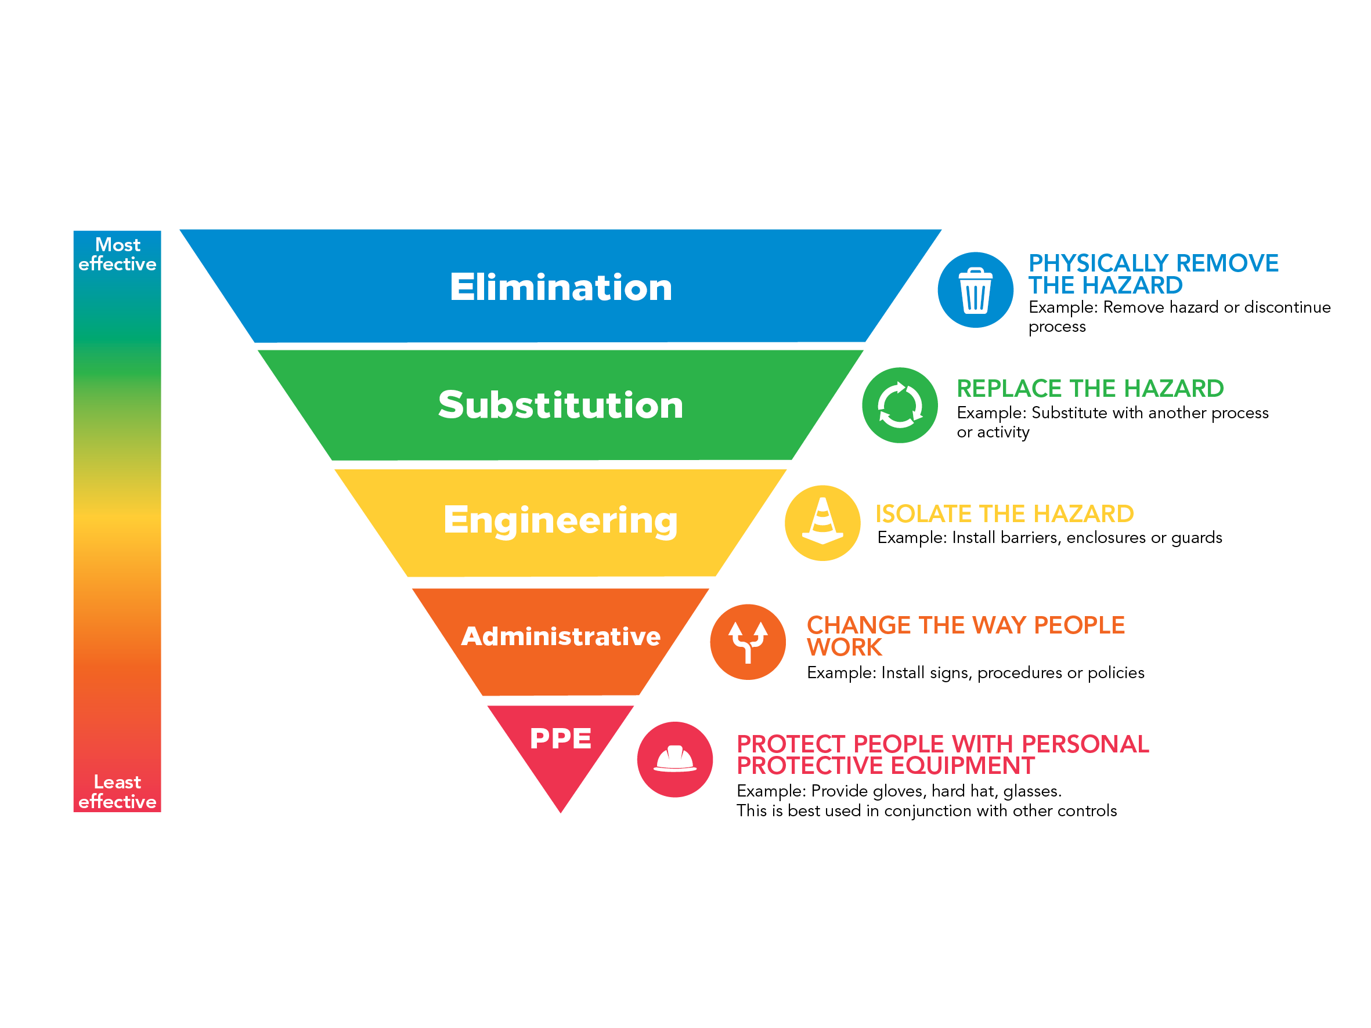

Event Risk
Management

<Enter event Name>*
<Enter event Date>*
<Enter event Location>*

You may choose to include your COVID Safe Plan in this Risk Management Plan or you may choose to complete it as a separate document. However, COVID Safe considerations must be taken into account when planning your event and included as part of your risk management documentation.

How to use this template

This document, when completed will provide you and other stakeholders with the information necessary to run a safe and successful event.

All sections marked with an asterisk (*) are mandatory and must be completed. If a section of this form is not applicable to your event, enter NOT APPLICABLE.

If this is your first time compiling an Event Risk Management Plan, this process will give you the opportunity to document all aspects of your event. If this has been done before, then information can be copied from previous years provided it is still relevant.

If you require any assistance in completing your Event Risk Management Plan, please contact the Governance & Risk Unit on 5018 8100.

This COVID-Safe Event Plan section of this template has been developed from the DHHS template as a guide only, to assist applicants to identify and manage COVID related risks only. Council accepts no legal liability for any of the information provided in your COVID-Safe Event Plan, and all actions, identified or otherwise, remain the responsibility of the applicant to manage and control.

For further information and guidance on addressing the 6 COVIDSafe Principals, please visit the Department of Health and Human Services (DHHS) website: https://www.dhhs.vic.gov.au/

Once this document has been completed, please return to;

Mildura Rural City Council
PO Box 105
MILDURA VIC 3502
Email: MRCC@mildura.vic.gov.au

This document must be submitted to Council at least 30 days before the scheduled event.

Event Information
Name of Event:*
Organisation/Hirer:*
Location of Event:*
Provide a description of the event including the type of activities and entertainment:*
Date of event:*
Event start time:* |  |  | Event finish time:*
Bump in (set up) will commence at:* | Time: |  |  | Date:
Bump out (pack up) will conclude at:* | Time: |  |  | Date:
Estimated number of attendees:*
Risk Assessment Process
Step 1 – Identify the Risks
A site visit prior to the event will help to identify potential risks, then thought should be given on ways to minimise them. You will be able to identify a number of risks, such as areas that need fencing off, inappropriate placement of proposed activities (i.e. trees overhead), or accessibility for emergency services to enter venue.

Using Table 1: Examples of Hazards, Risks and Controls as a guide, fill in the Hazards/Sources and Risks columns by listing those relevant to your event in the Risk Assessment Template located on page 14.

Step 2 – Rate the Risks
A risk rating is determined by considering the likelihood and consequence of an incident occurring.

Refer to Table 2: Risk Rating Matrix for definitions of each category, then fill in column 3 ‘Risk Rating’ of the Risk Assessment Template.

Step 3 – Identify Controls
To determine which controls will be implemented, consider what you are going to do to:
- Reduce the likelihood of the risk happening; or
- Reduce the consequences should the risk eventuate

Fill in column 4 ‘Risk Controls’ of the Risk Assessment Template using the examples in Table 1 as a guide.

Step 4 – Rate the Risks with controls
Now determine the risk rating after taking into consideration the controls you identified in step 3.

Fill in column 5 ‘Risk Rating’ of the Risk Assessment Template with your revised risk rating.

Step 5 – Control Responsibility
Nominate who will have ‘Responsibility’ in column 6 of the Risk Assessment Template. This person is responsible for ensuring the controls are implemented.
What is a Risk?
A risk is anything that threatens or limits the ability of an organisation (or Event Organiser) to achieve the successful running of the event.

What is Risk Management?
Risk management is a process of assessing all possible risks, problems or disasters before they happen and implementing controls to avoid or minimise the likelihood and consequence of the risks occurring.

Why do we need a Risk Management Plan?
There are a couple of key reasons why an Event Organiser needs to consider risk management for their event.

- To create an enjoyable experience for everyone
- To ensure that no-one gets hurt
- To minimise the chance or avoid being sued

Insurance is not a substitute for risk management

Event Planning Guide
If you are thinking about organising an event within the Mildura region, the Event Planning Guide is the best place to start.

The guide highlights key considerations for event organisers including planning, running and promoting a professional, safe & successful event.

The guide also contains a range of links to useful resources.

A copy is available on Council’s website.
Planning a Safe Event
All reasonable care should be taken to ensure your event is safe for all involved. This applies to event staff, volunteers, performers, the audience and the public in surrounding areas. There are also resources online that are designed to assist Event Organisers to plan for safe events such as the free Worksafe publication: Advice for Managing Major Events Safely.

Table 1: Examples of Hazards, Risks and Controls
The following table provides Event Organisers with examples of hazards / risks and corresponding control strategies that may be put in place for their event.
This list is not exhaustive. As an Event Organiser, you should use these examples as a starting point in the risk assessment process. Discussion should then take place with other people involved in planning and delivering the event to identify other relevant hazards specific to the nature of your event.

Hazard / Source | Example Risks | Example Controls
Persons unfamiliar with the venue, event or co-workers | - Hazards not known  - Slower reaction in an emergency | - Check with Council for known hazards and any past incidents  - Check with people who have held the event in the past and/or past event debriefs  - Communicate safety procedures to all stakeholders, including emergency procedures  - Establish coordination / communication systems (e.g. meetings, email/sms groups, names and photos of key people on noticeboards)  - Provide identifying badges or clothes for workers  - Conduct training for employees, volunteers and contractors (Induction, Venue specific, Task specific, and Emergency Procedures)
Interaction with adjacent businesses, residents or events | - Traffic management  - Fire  - Noise  - Fumes | - Check for other events that may impact on this event at planning stage (e.g. railway or roadworks that will impact on access)  - Clarify whether the event will have exclusive/non-exclusive use of the venue. If non-exclusive, coordinate with other users  - Consider how neighbouring residents, businesses and activities impact on this event
Persons become complacent in bump out phase | - Mental and physical fatigue  - Time pressures to return venue to pre-event state  - Bump out occurs at same time crowd is exiting  - Many stakeholders recovering equipment simultaneously | - Roster personnel to manage fatigue  - Roster personnel to supervise bump out phase  - Establish realistic timeframes to return the venue to pre-event state in consultation with venue manager and other stakeholders  - Plan timing and traffic management of bump out and retrieval of equipment so it does not conflict with exiting crowds
Structures, fences, stacked materials, etc collapsing | - Collapse of structures  - Crushing injury to public or participants | - Structures constructed by staff or contractors with relevant qualifications  - Structures erected according to building regulations  - Use of materials with manufacturer’s specifications  - Quantities of materials and fencing to be stacked flat to prevent collapse  - Managers and staff monitor all structures
Cooking, candles, naked flame, hot surfaces | - Burn injury  - Fire to start and be uncontrollable | - Stalls, food vendors and power supplies having dry chemical extinguishers and blankets at all risk areas  - Access routes for emergency vehicles to be made available through event areas  - BBQs to be guarded and out of public reach and fire contained so it can’t blow onto public  - All hot surfaces and naked flame to be out of reach of public
Slip, Trip, Fall and Knock | - Bodily injury to public or participants | - Serious trip and fall hazards identified prior to event and removed or treated to prevent injury  - Staff site safety induction  - Cables installed overhead where possible  - Rubber mats and cable traps over cables on ground  - Barriers placed around protruding equipment  - Changes in height and edges highlighted or barricaded  - Slippery surfaces treated or isolated  - Additional lighting in dark areas  - Spills isolated then cleaned by crews as soon as reported
Weather | - Heat stress  - Flooding  - Fire  - High Wind  - Lightning  - Falling trees or debris  - Excessive sun exposure | - Set up electrical equipment so it is not exposed to rain or flooding  - Determine contingency plans if there is a fire ban (e.g. cancel with appropriate communication, alter event (e.g. go indoors, do not use BBQs), continue with written permission from fire authority)  - Monitor weather forecast and determine pre-event action if certain weather events occur or are likely  - Provide shelter from sun and rain  - Provide drinking water for patrons and workers  - Provide weather appropriate clothing for workers  - Hold the event at a time that will minimise risk of weather impact  - Communicate weather related precautions that patrons should consider (e.g. bring a hat, sunburn cream, poncho) Consider selling / providing to patrons at the event.  - Avoid placing vendors and activities near trees
Traffic Management | - Impact between pedestrians and vehicles or 2 vehicles | - Develop traffic management plan. Include:  - Segregation of exiting pedestrians and bump out traffic  - No go zones for certain locations or phases (e.g. no heavy equipment movement during event)  - Liaise with public road authorities (e.g. VicRoads, Police)  - Signage & Barriers  - Parking and/or public transport options  - Vehicle access accreditation  - Staffing  - Monitoring of conditions  - Communication  - Reduced speed limit
Crowd Control | - Overcrowding  - Crushing (people pressed against object)  - Incidents outside event boundaries | - Appropriate layout and space allocation  - Allocated entry & exit routes  - Provide clear queuing system  - Provide timely information to patrons (e.g. signs, PA)  - Provide sufficient workers to manage crowds
Alcohol & Illicit Drugs | - Negative consequences of intoxicated behaviour  - Alcohol served to minors  - Negative effects including dehydration, potential medical concerns, crowd disturbances or violence | - All service staff are RSA qualified  - Plastic cups used in large-scale public events to lessen risk of injury and ensure compliance with liquor licensing  - Safety notice in program about appropriate use of alcohol and attitudes to drink-driving  - Reputable Security Company patrolling event for service compliance and inappropriate behaviour  - Set up event site to avoid secluded areas where illicit drugs can be exchanged / consumed  - Train personnel in recognising signs of illicit drug consumption and most appropriate response  - Liquor in public place permit obtained  - All bags are subject to search at the entrance
Live electrical wires or faulty equipment | - Electrocution hazard to patrons or performers  - Unauthorised persons access electrical fittings  - Contact with overhead wires | - Identify and communicate locations of overhead wires  - All installations to be carried out by qualified electrical contractors  - All leads and appliances to be tagged and tested  - All electric’s to be installed in accordance with appropriate regulations  - Temporary installations to run overhead where possible
Amusement Rides | - Clearance between rides, fixed structures and vegetation  - Stability of the ride - firmness and slope of the ground and blocking of the ride  - Poor maintenance  - Poor training and operational procedures  - Missing labels or warning signs  - Poor location of fencing or barricades | - Provide adequate space for rides  - Check ground is appropriate  - Place in contract / hire agreement and confirm:  - The ride has been maintained and set-up in accordance with the manufacturer’s instructions;  - Check areas not readily visible to ensure proper maintenance has been undertaken;  - Issues identified in the engineering assessment have been addressed;  - All operators and supervisors have been trained; and  - Adequate levels of supervision are available at all times
Manual Handling | - Sprains, strains, etc | - Minimise movement of material  - Provide loading/unloading areas as close to final location of material as possible  - Provide mechanical aides (e.g. forklift, trolley)  - Provide sufficient people and time to carry out tasks
Contact with biological hazards | - Clean up body fluids  - Sharps  - Insects  - Dogs / cats  - Snakes | - Develop procedures for cleaning up body fluids and provide equipment and training  - Provide sharps containers (fixed for patrons as appropriate and portable for workers with tongs and PPE)  - Communicate to patrons rules for animals (e.g. no dogs / dogs on leads only, etc)
Evacuation areas | - Insufficient safe areas / evacuation zones | - Event Organiser to provide site map to all staff, volunteers and vendors  - Sufficient space identified for evacuation site where there will be no infrastructure
Car parking | - Inadequate parking space | - Adequate provision reserved for car parking  - Car parking managed by experienced external organisation
Food | - Food poisoning  - Lack of food available | - Sufficient quantity of vendors sourced  - All food vendors have food handling certificates  - Copy of food vendors current public liability certificate  - Food vendors have adequate refrigeration / cooling for their requirements  - Adequate hand washing facilities have been provided for food vendors
Noise | - Disruption from sound of entertainment  - Unable to communicate to patrons | - Have a backup system in place
Signage | - Ineffective signage | - Allow sufficient time for planning, proofing and production of signage  - Use of reputable and certified company for printing and installation  - All signage is secured and weighted
Children’s  Activities/  Workshops | - Inappropriate or dangerous activity | - Activities run by professional organisation/staff  - Parents informed they must supervise their own children at all times
Children | - Lost or missing children | - ID Wristbands at front entrance  - Clearly marked Information Tent for lost children  - Staff and volunteers briefed on lost children response plan
Communications | - Lack of effective communication onsite | - Use of two-ways and mobile phones  - PA System / Megaphone onsite
Medical | - Ineffective, unprofessional personnel or service | - First Aid kit onsite for duration of event  - St John Ambulance and/or off duty ambulance officer in attendance  - Emergency contact numbers held by Event team  - Egress maintained for First Aid vehicle and emergency vehicle to access First Aid treatment space  - First Aid positioned in signed, accessible and central location onsite
Amenities | - Insufficient amenities | - Supply of sufficient number of toilets for expected number of patrons  - Clearly signed amenities and information about nearby alternative toilets  - Cleaner contracted to clean and maintain toilets  - Accessible toilets provided for people with limited mobility
Waste | - Insufficient waste disposal provisions | - Adequate quantity of bins placed throughout event  - Dedicated cleaning staff allocated to monitor and clear bins
Table 2: Risk Rating Matrix
The Risk Rating is determined where the relevant likelihood and consequence intersects.

 |  | Likelihood
 |  | Rare  Might occur but only in exceptional circumstances | Unlikely  Might occur but only in unusual circumstances, strong uncertainty | Possible  Might occur in certain circumstances | Likely  Will probably occur in normal circumstances | Almost Certain  Expected to occur in most circumstances
Consequences | Critical  Loss of life or multiple loss of life to public / workers. Life threatening injury / illness to public / workers | High | High | Extreme | Extreme | Extreme
 | Major  One or more public / workers requiring hospitalisation and immediate medical treatment with the potential for long term incapacitation | Medium | High | High | Extreme | Extreme
 | Moderate  Harm, injury or illness requiring professional medical treatment for public/workers | Low | Medium | Medium | High | High
 | Minor  Minor harm or injury where first aid is required for public/workers | Low | Low | Medium | Medium | High
 | Insignificant  No harm, injuries or ailments requiring treatment to public/workers | Low | Low | Low | Medium | Medium

Risk Rating | Suggested Actions Required
Extreme | Immediate action required to manage risk
High | Urgent action required to manage risk
Medium | Action required to manage risk
Low | Risk within acceptable level*
*Although the risk is within an acceptable level, it is recommended to implement practical controls to further reduce the likelihood and/or consequence where possible
Risk Assessment ~ All columns MUST be completed
- Hazard / Source*  List individual tasks or activities | - Risks *  Identify the potential risks associated with each task / activity. | - Risk Rating*  Before Controls  - Low  - Medium  - High  - Extreme | - Risk Controls *  Controls to address identified risks | - Risk Rating *  After Controls  - Low  - Medium  - High  - Extreme | - Responsibility *  Name of person responsible for implementing risk controls
Example:  Food | Food poisoning | Medium | - Ensure all food vendors have appropriate food licences  - Food vendors have adequate refrigeration / cooling for their requirements  - Adequate hand washing facilities have been provided for food vendors | Low | John Smith
 |  | Choose an item |  | Choose an item
 |  | Choose an item |  | Choose an item
 |  | Choose an item |  | Choose an item
 |  | Choose an item |  | Choose an item
 |  | Choose an item |  | Choose an item
 |  | Choose an item |  | Choose an item
 |  | Choose an item |  | Choose an item
 |  | Choose an item |  | Choose an item
 |  | Choose an item |  | Choose an item
 |  | Choose an item |  | Choose an item

COVIDsafe Plan (note – if you have a separate COVID Safe plan, you do not need to include the detail in your Event Risk Management Plan)
- Hazard / Source*  List individual tasks or activities | - Risks *  Identify the potential risks associated with each task / activity. | - Risk Rating*  Before Controls  - Low  - Medium  - High  - Extreme | - Risk Controls *  Controls to address identified risks | - Risk Rating*  After Controls  - Low  - Medium  - High  - Extreme | - Responsibility *  Name of person responsible for implementing risk controls
Example:  Physical Distancing | Attendees too close. Density quotients not managed | Low | - Each group maximum to be 25 people  - Density quotient to be followed as per venue requirements  - Physical distancing signage at each venue  - One team member per group  - Group leader to brief group and enforce 1.5m on walk | Low | Event Team  Venues
Physical Distancing |  | Choose an item |  | Choose an item
Face Coverings |  | Choose an item |  | Choose an item
Practice Good Hygiene |  | Choose an item |  | Choose an item
Keep Records and Act  Quickly |  | Choose an item |  | Choose an item
Event Workforce Bubbles |  | Choose an item |  | Choose an item
 |  | Choose an item |  | Choose an item
 |  | Choose an item |  | Choose an item

Please insert more lines if necessary

Public Liability Insurance

Have you provided evidence of appropriate Public Liability Insurance for your event? * ☐ Own Policy ☐ Cover under Council’s Policy

Have Public Liability Insurance Certificates of Currency been provided from all external parties?* ☐ Yes ☐ No

Declaration

I verify that I have, to the best of my knowledge endeavoured to anticipate all possible risks relevant to the above event and will ensure all controls listed above are implemented.
Event Organiser: |  | Organisation:
Signature: |  | Date:

Disclaimer
This template has been developed as a guide only, to assist Event Organisers to identify and manage risks associated with their event. The table of example hazards, risks and controls is not exhaustive. Event Organisers must comply with all Health and Safety legislation that is applicable to the running of an event. Council accepts no legal liability for any of the information provided in your Risk Management Plan, and all risks, identified or otherwise, remain the responsibility of the Event Organiser to manage and control.

