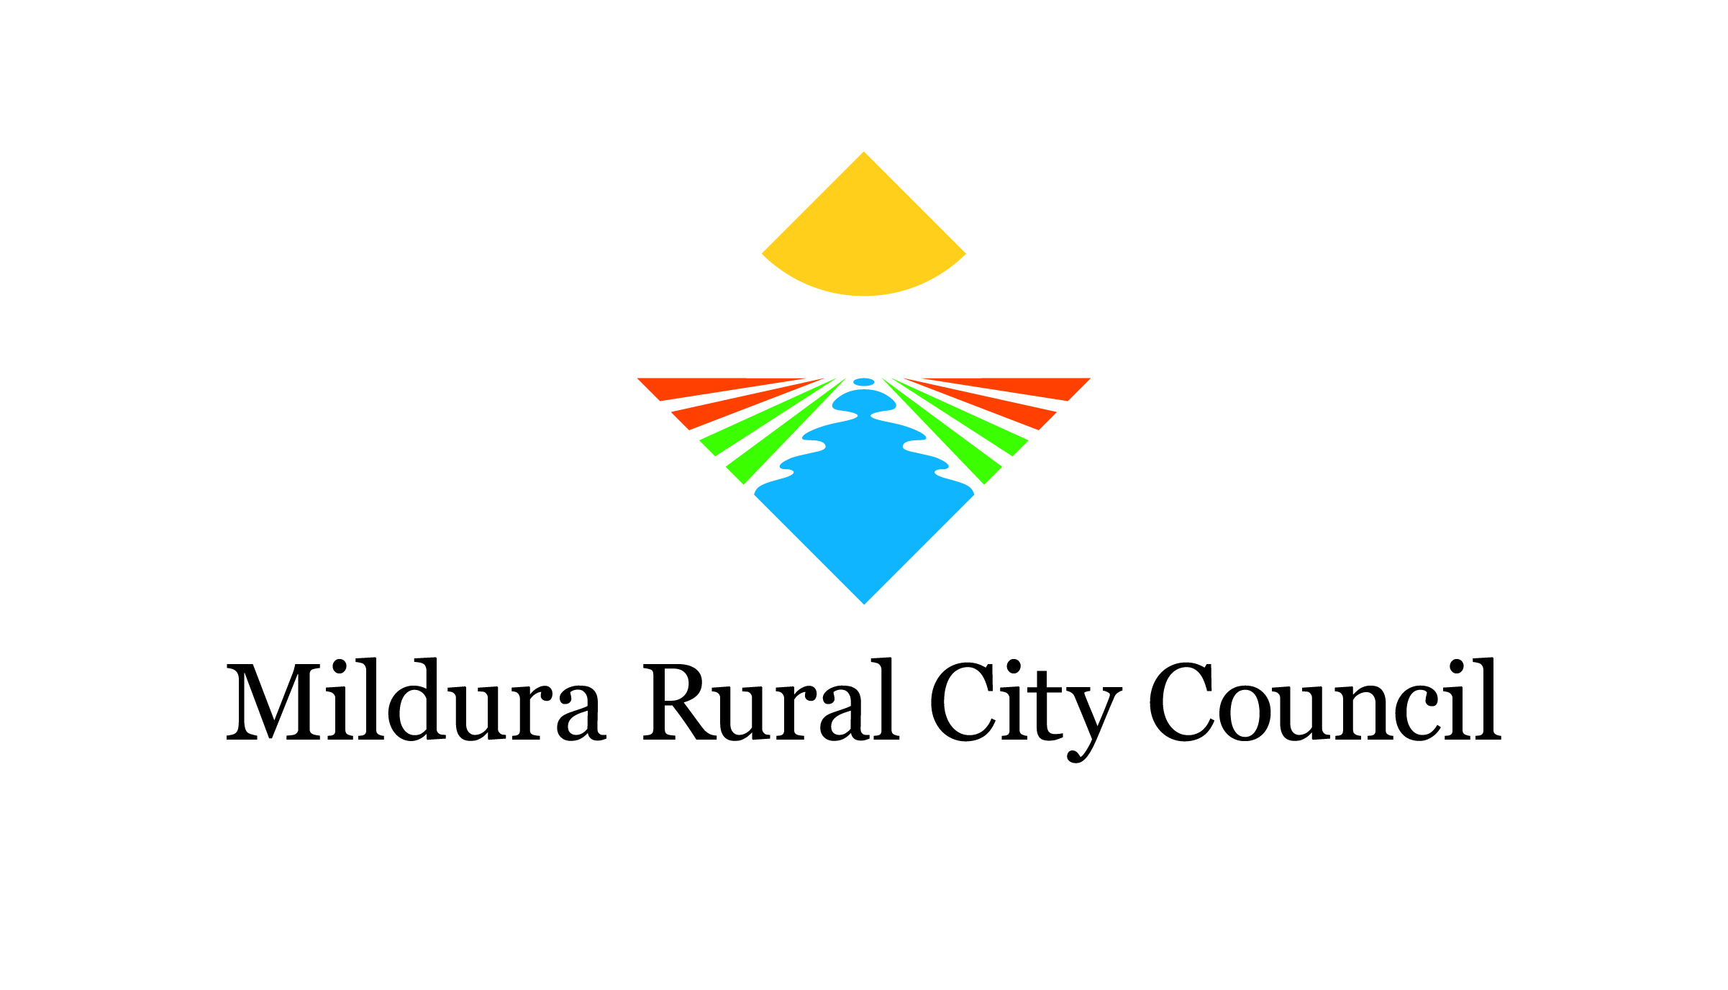
sponsor survey template

[Your Event] Sponsor Survey

The committee would like to thank you for supporting this year's [Your Event].
To ensure the community and committee can continually improve and grow the event, we invite you to provide feedback on your experience via our quick survey.

1. What is your company's name and where are you based?

2. How long have you been a partner of [Your Event]?
This was our first year
2 years
3+ years

3. What are your desired outcomes from a partnership with [Your Event]?
Brand awareness
Community engagement
Opportunity to sell at the event
Launch a product/service
Other (please specify)

4. How do you rate your outcomes from the partnership?
Excellent
Good
Satisfactory
Poor

5. How can we enhance the partnership arrangement to assist you with your objectives?

6. At this stage, are you considering a partnership with the event in [insert the year of the next event]?
Yes
No

7. Do you have any recommendations on how organisers can enhance the event?

