Site Map – Langtree Mall
To use this site map, simply copy and paste the below provided symbols placing them in the relevant locations for your event. There are also a range of additional symbols to use for other key points specific to your event
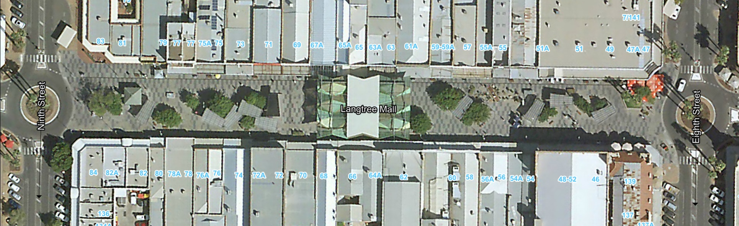

 | Audience seating & viewing |  | Playground
 | Coordination centre |  | Potable water
 | Electricity |  | Restricted area
 | Emergency assembly point |  | Stage
 | Emergency exit |  | Stall Holders
 | Emergency services access |  | Toilets
 | Entry & exit points |  | Vendor access
 | Fire extinguisher |  | Walking path
 | First Aid | 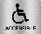 | Wheelchair access
 | Food/beverage vendors
 | Jumping Castle
 | Lost and found
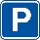 | Parking

