Hattah Land Use Plan – Frequently Asked Questions

What is the project?
The project will investigate and provide recommendations and strategic justification for the introduction of appropriate planning zones to address existing zoning anomalies in the Hattah Township and 174 Cootamundra Avenue, Red Cliffs.
Both areas are zoning anomalies where private land is incorrectly contained within the Public Conservation and Resource Zone (PCRZ), a zone which is otherwise consistent with the surrounding conservation land.
The project’s key objectives are to:
- Undertake the necessary background research to ensure all relevant issues are identified;
- Identify the strategic and visual importance of the precinct;
- Confirm the strategic basis for the land uses within the precinct;
- Identify the long term preferred land use vision and development future for the land;
- Identify realistic development options for the land and an appropriate zoning regime to realise its attainment;
- Establish sound planning and design and development principles and planning responses to guide future development and ensure that future use and development of the land occurs in a manner that reflects the preferred land use vision;
- Identify and detail any consequential changes which need to be made to the Mildura Planning Scheme;
- Recommend appropriate planning pathway for each study area;
- Consolidate recommendations in appropriate land use plan or like document, for each of the study areas.

What is the study area?
The study area comprises land within the boundary of the Hattah Township and 174 Cootamundra Avenue, and appropriate interfacing land.
Figure 1 – Project Area Map – Hattah Township
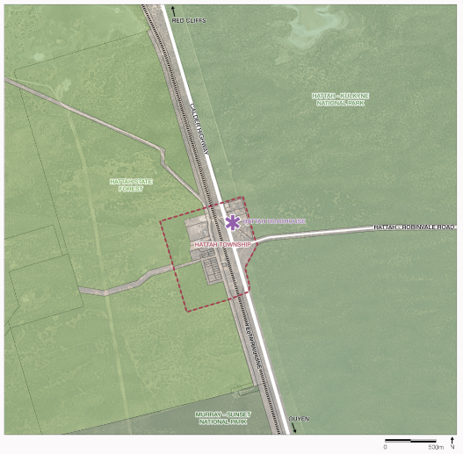

Figure 2 – Project Area Map – 174 Cootamundra Avenue
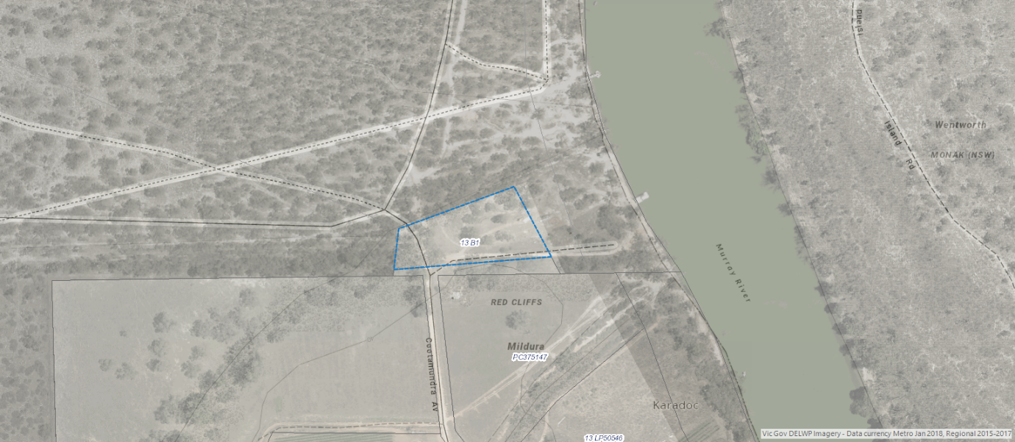

What are the zones?
Council rezoned areas of Hattah township from the Rural Zone to PCRZ in 1999. This rezoning has not changed since.
The Hattah land is contained within two zones in the current Mildura Planning Scheme:
- Road Zone 1 for land comprising both the Calder Highway and Hattah-Robinvale Road corridors.
- PCRZ for all other land.
The parcel at 174 Cootamundra Avenue Red Cliffs is contained within the PCRZ, including a portion of road adjoining the southern lot boundary. The DELWP-owned land surrounding the site to the north, is also zoned PCRZ.

What is the PCRZ?
In accordance with Clause 36.03 of the Mildura Planning Scheme, the purpose of the PCRZ is:
- ‘To protect and conserve the natural environment and natural processes for their historic, scientific, landscape, habitat or cultural values.
- To provide facilities which assist in public education and interpretation of the natural environment with minimal degradation of the natural environment or natural processes.
- To provide for appropriate resource based uses.
The PCRZ is a Public Land Zone within the Planning Scheme, intended to apply to public land. It is restrictive in nature with most uses prohibited.
MRCC hosts approximately 40% of the total area of the Victorian Parks system. The major parks include the Hattah-Kulkyne, Murray-Sunset and Wyperfield National Parks, Big Desert Wilderness Park and the Murray-Kulkyne Park. All of these parks are the subject of an overall management plan and contain highly significant landscape, flora, fauna and cultural values. They represent the least disturbed Mallee ecosystems in Australia.
In the Mildura Planning Scheme, Clause 21.05-4 Public Land includes objectives with respect to both protection of the environmental, landscape, cultural heritage and archaeological value of public land while supporting opportunities for tourism and improvement of the interface between public and private lands.

Why does this matter?
MRCC is the responsible authority for development in accordance with the Mildura Planning Scheme. Orderly planning relies on correct zoning to provide appropriate guidance.

Will any overlays be reviewed as part of the project?
The Hattah Township and all of the immediately surrounding land is contained within the Bushfire Management Overlay (BMO). The BMO will be reviewed as part of the project.
The parcel at 174 Cootamundra Avenue Red Cliffs and all of the surrounding land is not contained within the BMO.

Why now?
The project is a high priority for Council. During the recent review of the Mildura Planning Scheme undertaken by Ethos Urban in 2018-2019, one submission was received in relation to the zoning of the Hattah Township and an additional submission was received in relation to the zoning of 174 Cootamundra Avenue. Both submissions highlighted the need to confirm ownership and consider zoning. In response, the report acknowledged both the anomaly and the need for further work.

Will stakeholders have an opportunity to provide input?
This project provides the opportunity for interested persons to participate in the planning process. Engagement is focussed on landowners, community and relevant government stakeholders. Local residents are able to provide input via a survey or may get in contact with Council via phone or email. Phone interviews will be undertaken with government stakeholders who are landowners or Statutory Authorities.
When the draft Hattah Land Use Plan is placed on exhibition, community and stakeholders will be able to review and provide comments on the proposed zoning and overlays, which will be recommended during this process.
A Planning Scheme Amendment (PSA) will be required to change the zoning. This is the first stage in the rezoning. There will be further opportunity to engage when the PSA is placed on exhibition. This is likely to occur in early 2021.

When will the new zoning be implemented?
Full completion of this project, including adoption by Council, is anticipated to take 12 months from commencement. The new Council will make a decision on the PSA recommendations (this project) in early 2021.

Map created by GHD using VicPlan data (August 2020)
Map sourced from VicPlan (August 2020)

