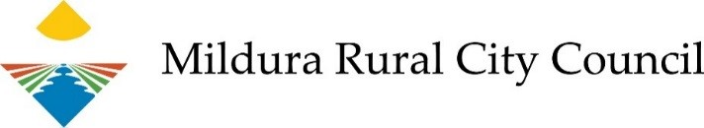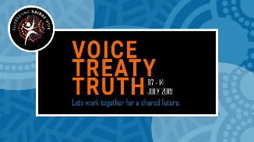

NAIDOC Week Community Event Application Form
Council is working with the Aboriginal Action Committee to deliver this year’s NAIDOC Week Corroboree Community Event on Sunday 7 July. The event will be held at Nowingi Place on the Mildura riverfront and run from 1pm to 5pm. If you would like to be involved please answer all questions and provide all information requested on this application form.
Section 1 : Applicant Information
Organisation name (if applicable):
Contact:
Phone:
Email Address:
Section 2 : Criteria
Describe your proposed activity, stall, workshop or performance:
(25%)
Describe how your proposed activity engages people in Aboriginal culture:
(25%)
Describe your involvement within or connection to the local Aboriginal community:
(25%)
Tell us about your experience delivering the proposed activities:
(25%)
Section 3: Entertainment Management
Do you have your own marquee, chairs and tables if required? |  |  | No |  | Yes
Do you need access to power? |  |  | No |  | Yes
Do you need access to water? |  |  | No |  | Yes
Section 4: Public Liability Insurance

All participants must have public liability insurance that covers their duty of care for all persons who will be involved in the activities they plan to hold at the event.

If you do not have your own public liability insurance you will be able to purchase a once off event insurance cover through Council. The cost of this policy is $33.00 (GST inclusive) per stall. A summary of cover is available upon request. Please be aware that to make a claim on the policy you are liable for the first $250 by way of a policy excess.
Please nominate which public liability insurance cover you wish to provide by ticking the appropriate box below:
Provide details of own policy Take out cover under Council's policy
(minimum $10m)
Comments:
Section 5: Finalising Your Application Form
How did you find out about this opportunity?

Social Media
Newspaper
Word of Mouth
Email
Other
Applications will be assessed on the weighted criteria identified within the application form. Applications will be assessed by a panel on Friday 24 May 2019. Please submit your application prior to this date.

Thank you for completing this application to express your interest in providing services for the Mildura Rural City Council Community NAIDOC Week event.

DECLARATION:
I declare that I am authorised to submit an Expression of Interest to provide my services for the Mildura Rural City Council Community NAIDOC Week event.

Print your full name:
Signature:
Date:
Please return completed application form to:
Mildura Rural City Council
PO Box 105
MILDURA VIC 3502
Email: mrcc@mildura.vic.gov.au
If you require assistance to complete your application form please contact Council’s Community Futures Unit on 03 5018 8100.

