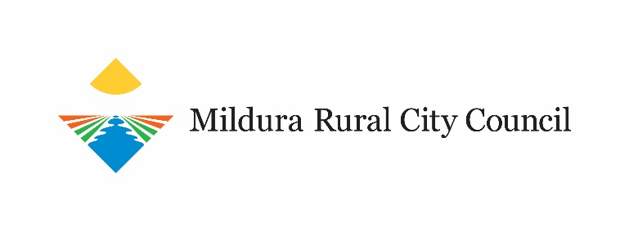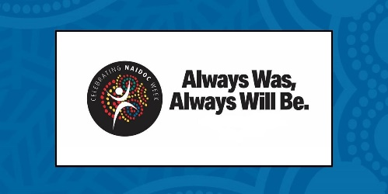

NAIDOC 2020 Event Application Form
NAIDOC 2020 celebrations will be delivered in partnership with Mildura Rural City Council’s Aboriginal Action Committee. This year’s NAIDOC celebrations will be an online initiative which will provide our community with opportunities to respond creatively to new and changing circumstances during COVID-19.

The theme for NAIDOC 2020 is ‘Always Was, Always Will Be.’

This online series invites all community to embrace the true history of our country by participating in a range of cultural activities from podcasts to video productions, artist’s commissions, workshops and storytelling.

If you would like to participate in NAIDOC 2020, please complete the details in this form. Any questions, please contact Kerren Miles by email at kerren. miles@mildura.vic.gov.au

PROJECT FEE
A project fee will be paid to all successful participants in NAIDOC 2020.
You must complete the form and submit by 4pm, Thursday 1 October 2020.

BY MAIL: BY EMAIL:
NAIDOC 2020 Expressions of Interest mrcc@mildura.vic.gov.au
Mildura Rural City Council
PO Box 105, Mildura VIC 3502

MILDURA RURAL CITY COUNCIL
PRIVACY COLLECTION STATEMENT

Mildura Rural City Council collects Personal and or Health Information for municipal purposes as specified in the Privacy and Data Protection Act 2014. The information collected in this form is used only for the purposes specified (primary purpose) and is not passed on to third parties. Council may disclose this information, but only if authorised or required by law. Council may not be able to process your request unless sufficient information is given. Should you need to change or access your personal details, or you require further information regarding Council’s Privacy Policy, please contact Council’s Privacy Officer.

Section 1 : Applicant Information

Name
Address
Telephone
Mobile
Email address
Business Name if applicable
ABN if applicable
Website
(inc. YouTube/Facebook if applicable)

Section 2 : Art Category

Which of the following best describes your category of art?
Tick the box that applies to you
- Painter
- Photographer
- Drawer
- Sculptor
- Printmaker
- Video
- Weaver
- Dancer
- Musician
- Singer
- Story Teller
- Smoking ceremony
- Other:_____________________________________________________

Section 3: Project Details tio3: Project Details

PROJECT – Please provide details about your proposed online contribution such as format, length of clip or workshop or number of images for website.

Section 4: Online Options

Tick the box that applies to you
- Static Images on website
- Prerecorded event
- Live Streaming event
- Preferred day for live streaming event:

- Online artwork sales; please provide link to website or Facebook for sales

Section 5: Finalising your Application Form
How did you find out about this opportunity?

Social Media
Newspaper
Word of Mouth
Email
Other
Applications will be assessed by a panel on Friday 2 October 2020.

Thank you for completing this Application to express your interest in providing services for the Mildura Rural City Council online NAIDOC 2020 event.

DECLARATION:
I declare that I am authorised to submit an Expression of Interest to provide my services for the Mildura Rural City Council online NAIDOC 2020 event.

Print your full name:
Signature:
Date:
Please return completed Application Form to:
Mildura Rural City Council
PO Box 105
MILDURA VIC 3502
Email: mrcc@mildura.vic.gov.au
If you require assistance to complete your Application Form please contact Council’s Community Futures Unit on (03) 5018 8100.

