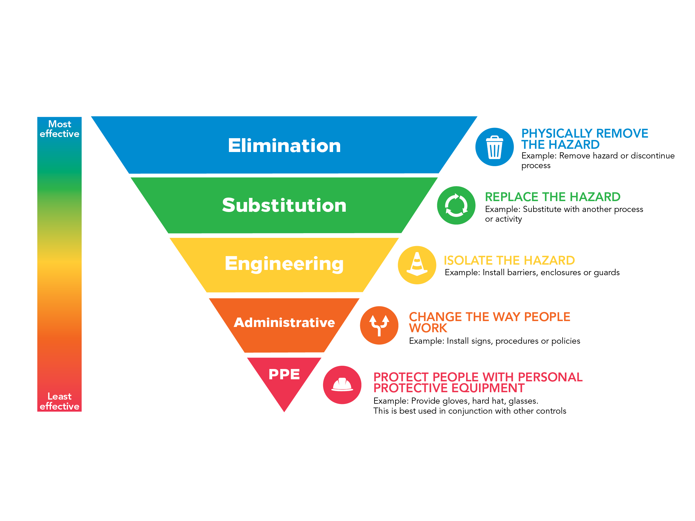

Event Emergency
Management Plan

<Enter event Name>*
<Enter event Date>*
<Enter event Location>*

How to use this template

An Emergency Management Plan is a vital tool of event planning. This plan will outline your response in the event of a serious incident in those critical minutes before emergency services arrive to take over.

The information below, once completed and signed, can act as your Emergency Management Plan. Please edit as appropriate and add more detailed information as required – each event will be different and there may be potential issues specific to your event that need to be addressed.

All sections marked with an asterisk (*) are mandatory and must be completed. Should a section of this form not be applicable to your event, enter NOT APPLICABLE. If there are sections that you are not sure about, contact the Governance & Risk Unit on 5018 8100 for further advice.

Once this document has been completed, please return to;

Mildura Rural City Council
PO Box 105,
MILDURA VIC 3502
MRCC@mildura.vic.gov.au
5018 8100

This document must be submitted to Council at least 30 days before the scheduled event.

Event Communications
All events must have a nominated Event Coordinator and a nominated Event Safety Officer

Event Coordinator Name:*
Mobile:*

Safety Officer Name:*
Mobile:*

Other roles that may be required given the size, complexity and nature of the event
First Aid Officer Name:
Mobile:

Area Warden 1 Name:
Mobile:

Area Warden 2 Name:
Mobile:

Area Warden 3 Name:
Mobile:

Area Warden 4 Name:
Mobile:

Emergency Assembly Point Locations
Provide location details for all emergency assembly areas, i.e. address or land marks

Assembly Area 1*
Assembly Area 2
Assembly Area 3
Assembly Area 4
Communication and Coordination
Describe the communications system which will be used between organisers, staff and volunteers. Eg. Two-way radios, mobile phones etc*

Describe the system to be used for communicating with the general public at your event.
Eg. PA system, megaphone etc*

Security and Crowd Management
Will security or crowd control be used for the event? If so, provide company details and contact information. *

Traffic Management
Are any temporary road closures planned for this event? How will this be managed? *

How will exhibitors, performers, staff, volunteers and emergency vehicles access the site?*

Lost Persons Procedure
Detail what will happen if a lost child or person is found, where they are taken to, what staff will look after them and how will you locate their parents, guardians or friends.*

Detail what will happen if a parent or guardian reports a lost child or person? *

Specific Emergency Procedures
The below checklists have been provided for event organisers who do not already have a specific emergency management plan for their event. You may use these checklists (amending as necessary) at your event should an emergency occur, or you can supply your own emergency management plan.

Fire
 | Response actions (amend as appropriate)
Discovery of a fire | ☐ Sound fire alarm
 | ☐ Call 000 to notify the fire brigade
 | ☐ If safe to do so extinguish the fire
On sounding the alarm | ☐ If threat to life exists, Event Coordinator or Safety Officer will lead all persons at event to the designated assembly point(s) immediately
 | ☐ Walk calmly and quickly and avoid panic
 | ☐ Ensure attendees with disabilities are assisted
 | ☐ Check that all areas have been cleared en-route to assembly point(s)
 | ☐ Ensure all attendees remain at the assembly point(s) until clearance to leave is given
Returning  to the site | Do not return to the building/site until given the all clear by the Fire Service

Gas Leak
 | Response actions (amend as appropriate)
If gas leak is suspected | ☐ Evacuate immediate area
 | ☐ Ensure attendees with disabilities are assisted
 | ☐ Call 000 to notify relevant Emergency Services
 | ☐ Remove ignition sources, only if safe to do so
 | ☐ Isolate gas/electricity supply, only if safe to do so
 | ☐ If threat to life exists, sound alarm for evacuation
 | ☐ Event Coordinator or Safety Officer will lead all persons at event to the designated assembly point(s) immediately
 | ☐ Check that all areas have been cleared en-route to assembly point(s)
 | ☐ Ensure all attendees remain at the evacuation point until clearance to leave is given
Returning  to the site | Do not return to the building/site until given the all clear by Emergency Services
Medical Emergency
 | Response actions (amend as appropriate)
Incident requiring emergency medical assistance | ☐ Ensure your own safety. Assess area for danger (eg. Live wires, poisonous substances etc)
 | ☐ If trained, provide first aid
 | ☐ Call Emergency Services on 000
 | ☐ Designate someone to meet the emergency services and direct them to the location of the casualty
 | ☐ Try not to leave the casualty until the emergency assistance arrives
 | ☐ Do not move casualty unless they are exposed to a life threatening situation

Extreme Weather
 | Response actions (amend as appropriate)
When severe storm threatens | ☐ Monitor Bureau of Meteorology website – www.bom.gov.au
 | ☐ Secure all items, if safe to do so
 | ☐ Shut off gas and electricity supply, if safe to do so
Storm approaches | ☐ Event Coordinator or Safety Officer to determine if event be cancelled
 | ☐ Advise all attendees of cancellation of event
On cancellation of event | ☐ Assist all attendees evacuate the site
 | ☐ If required and available, evacuate everyone to shelter until storm passes

Civil Disturbances
 | Response actions (amend as appropriate)
Disruptive person on-site | ☐ If security in attendance, notify security guard of incident and persons location
 | ☐ Contact Emergency Services on 000
 | ☐ Remain calm, do not do or say anything that will encourage irrational behaviour
 | ☐ If safe, move persons to predetermined safe position to await Police arrival
Bomb Threat
Keep calm. Do not hang up. Without alerting caller, signal co-worker to call 000.

Let the caller talk, ask questions as the opportunity arises and avoid being confrontational
Questions |  |  |  |  | Answers
When is the bomb going to explode?
Where is the bomb?
What does the bomb look like?
What kind of bomb is it?
What is the explosive type and quantity?
Why did you place the bomb?
What is your name?
Where are you?
What is your address?
Exact wording of the threat:
The Caller |  |  |  |  | Answers
Sex: |  |  |  |  | Male Female
Estimated age:
Any speech impairment (specify):
Accent (specify):
Voice – loud – soft etc:
Speech – fast – slow etc:
Manner, calm emotional etc:
Did you recognise the voice? |  |  |  |  | Yes No
If so who do you think it was?
Was the caller familiar with the area? |  |  |  |  | Yes No
Threat Language
Well spoken  Incoherent | Irrational  Taped |  | Message read by caller  Abusive |  |  |  | Other: _____________
Any background noises?
Street noise  House noise | Aircraft  Voices |  | Music  Machinery |  |  | Vehicle  Other: _____________
Call taken
Date: __/___/____ |  | Time: |  | Length of call: |  | Number called:

Fire Danger Period
During the months of October to April fire danger can be extremely high, the Country Fire Authority (CFA) must be consulted if the event is to be conducted on a day of total fire ban or during the fire danger period. Visit the CFA website for further information www.cfa.vic.gov.au

Has a day of total fire ban or fire danger period been considered?* ☐ Yes ☐ No

Has the fire service been consulted?* ☐ Yes ☐ No

Site Plan
IMPORTANT – It is a requirement that a site plan is developed. On this plan, locate and indicate all of the mandatory points below and any other important items. Tick the items after you have located them on the plan or leave blank if the item is not relevant.

This site plan is essential for emergency management. All staff/participants/performers are to be made aware of the Evacuation Plan and have knowledge of the evacuation procedures as well as a copy of the site plan prior to the event.

Layout of the venue* | ☐ |  | Stage | ☐
Fire Extinguishers | ☐ |  | Walking paths* | ☐
Emergency assembly points* | ☐ |  | Wheelchair access | ☐
Vendor stalls | ☐ |  | Coordination Centre | ☐
Emergency exits* | ☐ |  | Audience seating & viewing | ☐
Drinking water | ☐ |  | Restricted areas | ☐
First aid* | ☐ |  | Entry & Exit points* | ☐
Food & refreshments | ☐ |  | Toilets* | ☐
Play grounds | ☐ |  | Parking | ☐
Temporary structures | ☐ |  | Emergency vehicle access | ☐
Lost and found | ☐ |  | Vehicle access points | ☐

Site Plan *

Sketch your site plan in the space provided below, marking all mandatory points as identified on the previous page.

Key Contacts

This list should be used as a quick reference for staff and volunteers at the event, complete all fields relevant to your event.

Position / Organisation | Contact | Phone
Event Coordinator*
Safety Officer*
First Aid Officer
Area Warden 1
Area Warden 2
Area Warden 3
Area Warden 4
Mildura Rural City Council |  | 5018 8100
Victoria Police |  | 000
Ambulance |  | 000
SES |  | 13 25 00
Vic Roads |  | 13 11 71
CFA |  | 000
Taxi
Security
Poisons Information |  | 13 11 26
Plumber
Electrician
Other

Declaration

I/we agree to implement the procedures above in case of an emergency and will ensure that all key staff/volunteers will be given a copy of this plan prior to the event, as well as having copies of the plan available on the day of the event.
Applicant Name: |  | Organisation:
Applicant Signature: |  | Date:

Disclaimer
This template has been developed as a guide only, to assist Event Organisers plan emergency management procedures for their event. The suggested inclusions are not an exhaustive list of considerations. Council accepts no legal liability for any of the information provided in your Emergency Management Plan, and all procedures and actions, identified or otherwise, remain the responsibility of the Event Organiser to implement.

